Software Requirements Specification

for

On Spot Accident Reporting System

Version 1.0 approved

Prepared by: Vaibhav Bhujade

Veermata Jijabai Technological Institute

<date created>

Table of Contents

Table of Contents ii

Revision History ii

1. Introduction 1

1.1 Purpose 1

1.2 Document Conventions 1

1.3 Intended Audience and Reading Suggestions 1

1.4 Product Scope 1

1.5 References 1

2. Overall Description 2

2.1 Product Perspective 2

2.2 Product Functions **Error! Bookmark not defined.**

2.3 Operating Environment 2

2.4 Design and Implementation Constraints 3

2.5 User Documentation 3

2.6 Assumptions and Dependencies 3

3. External Interface Requirements 3

3.1 User Interfaces 3

3.2 Hardware Interfaces 3

3.3 Software Interfaces 3

3.4 Communications Interfaces 3

4. System Features 4

4.1 System Feature 1 **Error! Bookmark not defined.**

4.2 System Feature 2 (and so on) **Error! Bookmark not defined.**

5. Other Nonfunctional Requirements 4

5.1 Performance Requirements 13

5.2 Safety Requirements 13

5.3 Security Requirements 14

5.4 Software Quality Attributes 14

5.5 Business Rules 14

6. Other Requirements 14

Appendix A: Glossary 14

Appendix B: Analysis Models 15

Appendix C: To Be Determined List 15

Revision History

|  |  |  |  |
| --- | --- | --- | --- |
| **Name** | **Date** | **Reason For Changes** | **Version** |
|  |  |  |  |
|  |  |  |  |

# Introduction

## Purpose

An on-spot road accident reporting system. This system would help road accidents victims. Many a times a road accident victim is not taken care of due to jurisdiction fright and the accident is not even reported by the same, this system would allow common citizens to report accidents anonymously.

## Document Conventions

This document uses the following conventions.

|  |  |
| --- | --- |
| DB | Database |
| UID | Unique ID |

## Intended Audience and Reading Suggestions

This project is a prototype for an on-spot accident reporting system and it is restricted within the college premises. This has been implemented under the guidance of college professors. This project is useful for the transport authorities, law authorities, insurance companies and as well as to the common citizens.

## Product Scope

The purpose of the on-spot accident reporting system is to help accidents victims, making reporting accident hassle free and to facilitate co-ordination between various authorities such as transport authorities, ambulance and Police. Also, providing on-spot evidences which otherwise disappears due to late actions. The system is based on a relational database with its reported accident data. We will have a database server supporting major cities around the country. Above all, we hope to provide an effective and rapid action application.

## References

<https://standards.ieee.org/standard/830-1998.html>

# Overall Description

## Product Perspective

## 

USE CASE Diagram

## Operating Environment

Mobile application, android support for software and standard mobile hardware specifications.

## Design and Implementation Constraints

1. The global schema, fragmentation schema, and allocation schema.
2. SQL commands for above queries/applications
3. How the response for application 1 and 2 will be generated. Assuming these are global queries. Explain how various fragments will be combined to do so.
4. Implement the database at least using a centralized database management system.

## User Documentation

//To be published later

## Assumptions and Dependencies

# External Interface Requirements

## User Interfaces

* Front End: Android Studio Code,HTML,CSS
* Back End: PHP

## Hardware Interfaces

* Windows.
* A browser which supports CGI, HTML & PHP.

## Software Interfaces

<Describe the connections between this product and other specific software components (name and version), including databases, operating systems, tools, libraries, and integrated commercial components. Identify the data items or messages coming into the system and going out and describe the purpose of each. Describe the services needed and the nature of communications. Refer to documents that describe detailed application programming interface protocols. Identify data that will be shared across software components. If the data sharing mechanism must be implemented in a specific way (for example, use of a global data area in a multitasking operating system), specify this as an implementation constraint.>

## Communications Interfaces

<Describe the requirements associated with any communications functions required by this product, including e-mail, web browser, network server communications protocols, electronic forms, and so on. Define any pertinent message formatting. Identify any communication standards that will be used, such as FTP or HTTP. Specify any communication security or encryption issues, data transfer rates, and synchronization mechanisms.>

# System Features

**USE CASE SPECIFICATIONS:**

1. **REPORT INCIDENT-**
   1. Description – The most basic function of the on-spot accident reporting system, to report incident.
   2. Actors – Civilian
   3. Pre-Condition – GPS system and the camera of the device should be working.
   4. Basic Flow of interaction–

|  |  |  |
| --- | --- | --- |
|  | Actor | System |
| 1.4.1 | Clicks on Report Incident button | Provides two options. Reporting-self or Reporting-others. |
| 1.4.2 | Clicks on Reporting-others. | Provides two options. Major accident or Minor accident. |
| 1.4.3 | Clicks on major accident. | Access GPS location of the device and opens camera. |
| 1.4.4 | Clicks accident site photos. | Asks for additional information (Optional). |
| 1.4.5 | Enters additional information. | Registers the incident on the Database. Queued for authentication. |

* 1. Alternate or Exceptional flow –

|  |  |  |
| --- | --- | --- |
|  | Actor | System |
| 1.4.2.1 | Clicks on Reporting-self. | Provides two options. Major accident or Minor accident.  Continues 1.4.3 |
| 1.4.5.1 | Skips entering additional information. | Registers the incident on the Database. Queued for authentication. |

* 1. Post-condition – Display message “Incident Reported” and report reference is generated and incident is queued for authentication.
  2. Special Conditions – Same incident reported twice must be traced via GPS.
  3. Other Specifications-
     1. Frequency of use- High
     2. Complexity of use- Simple

1. **LOGIN-**
   1. Description – Provides an option for various actors to login.
   2. Actors – Police, Transport Authority, Ambulance, Insurance Company, Citizen.
   3. Pre-Condition – Actors must be Registered.
   4. Basic Flow of interaction–

|  |  |  |
| --- | --- | --- |
|  | Actor | System |
| 2.4.1 | Clicks on Login. | Provides three options: Authority Login, Citizen Login, Insurance Company. |
| 2.4.2 | Actors selects one of the option accordingly. | According to chosen option redirects to different use case according to actors. |

* 1. Alternate or Exceptional flow –

|  |  |  |
| --- | --- | --- |
|  | Actor | System |
| 2.4.2.1 | User does not select any of the options provided and reverts back. | Redirects to Authenticate User. |

* 1. Post-condition – All use cases are accessible depending on the user.
  2. Special Conditions – High security regarding user profiles.
  3. Other Specifications-
     1. Frequency of use- Low
     2. Complexity of use- Simple

1. **REGISTER-**
   1. Description – Gives an option for new user to register.
   2. Actors – Police, Transport Authority, Ambulance, Insurance Company, Citizen.
   3. Pre-Condition – Application must be preinstalled and actor must be on home window.
   4. Basic Flow of interaction–

|  |  |  |
| --- | --- | --- |
|  | Actor | System |
| 3.4.1 | Clicks on Register user. | Provides three options: Authority Registration, Citizen Registration, Insurance Company Registration. |
| 3.4.2 | User selects one of the three options provided. | According to chosen option provides registration data fields to be filled up. |

* 1. Alternate or Exceptional flow –

|  |  |  |
| --- | --- | --- |
|  | Actor | System |
| 3.4.2.1 | User does not select any of the options provided and reverts back. | Redirects to home page without any changes. |

* 1. Post-condition –Login use case is functional for the registered user.
  2. Special Conditions – Data fields must contain valid data input.
  3. Other Specifications-
     1. Frequency of use- Low
     2. Complexity of use- Simple

1. **AUTHORITY LOGIN-**
   1. Description – Login for Authorities.
   2. Actors – Police, Transport Authority, Ambulance.
   3. Pre-Condition – Actor must be Authority Registered.
   4. Basic Flow of interaction–

|  |  |  |
| --- | --- | --- |
|  | Actor | System |
| 4.4.1 | Clicks on Authority login. | Requirement of user id and password. |
| 4.4.2 | User provides user name and password. | Verify and logs in the user successfully. |

* 1. Alternate or Exceptional flow –

|  |  |  |
| --- | --- | --- |
|  | Actor | System |
| 4.4.2.1 | User enters invalid details. | Shows “Invalid Login Details” ,Continue 5.4.2 |
| 4.4.2.2 | Clicks on forgot password. | Verifies e-mail and resets password. |

* 1. Post-condition – All use case functionalities for Authorized User are displayed.
  2. Special Conditions – Single user should be logged in a single session.
  3. Other Specifications-
     1. Frequency of use- Low
     2. Complexity of use- Simple

1. **CITIZEN LOGIN-**
   1. Description – Login for Citizens.
   2. Actors – Citizen.
   3. Pre-Condition – Citizen must be registered to Login.
   4. Basic Flow of interaction–

|  |  |  |
| --- | --- | --- |
|  | Actor | System |
| 5.4.1 | Clicks on citizen login. | Requirement of user id and password. |
| 5.4.2 | User provides user name and password. | Verify and logs in the user successfully. |

* 1. Alternate or Exceptional flow –

|  |  |  |
| --- | --- | --- |
|  | Actor | System |
| 5.4.2.1 | User enters invalid details. | Shows “Invalid Login Details” ,Continue 6.4.2 |
| 5.4.2.2 | Clicks on forgot password. | Verifies through OTP. |

* 1. Post-condition – Home page is displayed.
  2. Special Conditions – Login doesn’t affect the use case functionality of Citizen.
  3. Other Specifications-
     1. Frequency of use- Very low
     2. Complexity of use- Simple

1. **INSURANCE COMPANY LOGIN-**
   1. Description – Login for insurance company.
   2. Actors – Insurance Company.
   3. Pre-Condition – Insurance Company must be Registered.
   4. Basic Flow of interaction–

|  |  |  |
| --- | --- | --- |
|  | Actor | System |
| 6.4.1 | Clicks on Insurance Company login. | Requirement of user id and password. |
| 6.4.2 | User provides user name and password. | Verify and logs in the user successfully. |

* 1. Alternate or Exceptional flow –

|  |  |  |
| --- | --- | --- |
|  | Actor | System |
| 6.4.2.1 | User enters invalid details. | Shows “Invalid Login Details” ,Continue 7.4.2 |
| 6.4.2.2 | Clicks on forgot password. | Verifies e-mail and resets password. |

* 1. Post-condition –All Use case functionalities of Insurance Company are displayed.
  2. Special Conditions – High security of login credentials.
  3. Other Specifications-
     1. Frequency of use- Moderate
     2. Complexity of use- Simple

1. **AUTHORITY REGISTRATION-**
   1. Description –Registration of Authority Users.
   2. Actors – Police, Transport Authority, Ambulance.
   3. Pre-Condition – Actor must have a valid ID from any of the mentioned departments/services.
   4. Basic Flow of interaction–

|  |  |  |
| --- | --- | --- |
|  | Actor | System |
| 7.4.1 | Clicks on Authority Registration. | Input details data fields form is generated. |
| 7.4.2 | User fills the requires details and submits. | Authority person successfully registered. |

* 1. Alternate or Exceptional flow –

|  |  |  |
| --- | --- | --- |
|  | Actor | System |
| 7.4.2.1 | User left mandatory fields empty and submits. | Redirects to 8.4.2 without any changes with a message “Fields cannot be left empty”. |
| 7.4.2.2 | Enters User Id | Entered User Id is not available.  Redirects to enter User Id |

* 1. Post-condition – Registration status is displayed.
  2. Special Conditions – High security for details, password encryption.
  3. Other Specifications-
     1. Frequency of use- Moderate
     2. Complexity of use- Simple

1. **CITIZEN REGISTRATION-**
   1. Description – Registration of Citizen.
   2. Actors – Citizen.
   3. Pre-Condition – Citizen must not have been registered earlier.
   4. Basic Flow of interaction–

|  |  |  |
| --- | --- | --- |
|  | Actor | System |
| 8.4.1 | Clicks on Citizen Registration. | Input details data fields form is generated. |
| 8.4.2 | User fills the requires details and submits. | Citizen successfully registered. |

* 1. Alternate or Exceptional flow –

|  |  |  |
| --- | --- | --- |
|  | Actor | System |
| 8.4.2.1 | User left mandatory fields empty and submits. | Redirects to 9.4.2 without any changes with a message “Fields cannot be left empty”. |

* 1. Post-condition – Displays citizen login page.
  2. Special Conditions – Response time must be less.
  3. Other Specifications-
     1. Frequency of use- Low
     2. Complexity of use- Simple

1. **INSURANCE COMPANY REGISTRATION-**
   1. Description – Registration of Insurance company.
   2. Actors – Insurance Company.
   3. Pre-Condition – Insurance company must not have been registered earlier.
   4. Basic Flow of interaction–

|  |  |  |
| --- | --- | --- |
|  | Actor | System |
| 9.4.1 | Clicks on Insurance Company Registration. | Input details data fields form is generated. |
| 9.4.2 | User fills the requires details and submits. | Insurance company successfully registered. |

* 1. Alternate or Exceptional flow –

|  |  |  |
| --- | --- | --- |
|  | Actor | System |
| 9.4.2.1 | User left mandatory fields empty and submits. | Redirects to 10.4.2 without any changes with a message “Fields cannot be left empty”. |

* 1. Post-condition – Displays insurance company login page.
  2. Special Conditions – Registration must be renewed every 6 months.
  3. Other Specifications-
     1. Frequency of use- Moderate
     2. Complexity of use- Simple

1. **CHECK FOR POLICY HOLDER-**
   1. Description – To check for policy holders for the authenticated incidents.
   2. Actors – Insurance Company.
   3. Pre-Condition – Insurance company must be registered and logged-in.
   4. Basic Flow of interaction–

|  |  |  |
| --- | --- | --- |
|  | Actor | System |
| 10.4.1 | Enters policy no. or policy holder name and search for incident. | Searches the incidents for policy holders and display related search result. |
| 10.4.2 | Clicks on specific search result. | Display required details of the incident. |

* 1. Alternate or Exceptional flow –

|  |  |  |
| --- | --- | --- |
|  | Actor | System |
| 10.4.2.1 | Enters policy no. or policy holder name and search for incident. | No matches found. “Search again”. Continue 11.4.2 |

* 1. Post-condition – Save incident details and redirect to check for policy holder use case.
  2. Special Conditions – Search result must be within a year from current date.
  3. Other Specifications-
     1. Frequency of use- High
     2. Complexity of use- Moderate

1. **AUTHENTICATE INCIDENT-**
   1. Description – Reported incidents are queued for verification.
   2. Actors – Police, Transport Authority, Ambulance.
   3. Pre-Condition – Incident must be reported before authentication and authority must be registered and logged-in.
   4. Basic Flow of interaction–

|  |  |  |
| --- | --- | --- |
|  | Actor | System |
| 11.4.1 | Reported incident is notified. | Notifies nearby authorities of the incident. |
| 11.4.2 | By checking the photos and the location details authenticates the incident. | Changes the reported incident status to authenticated incident. |

* 1. Alternate or Exceptional flow –

|  |  |  |
| --- | --- | --- |
|  | Actor | System |
| 11.4.2.1 | By checking the photos and the location details does not authenticate the incident. | Notifies to the reporter that the incident was unauthenticated. |

* 1. Post-condition – Generates a unique case no and redirects to File and Register Use Case.
  2. Special Conditions – Auto generation of Unique case No.
  3. Other Specifications-
     1. Frequency of use- High
     2. Complexity of use- Simple

1. **NOTIFY INCIDENT-**
   1. Description – Authenticated incidents are reported to other authorities. If Police has authenticated the incident Transport authority and Ambulance must be notified accordingly.
   2. Actors – Police, Transport Authority, Ambulance.
   3. Pre-Condition – Incident must be authenticated to be notified to specific authority.
   4. Basic Flow of interaction–

|  |  |  |
| --- | --- | --- |
|  | Actor | System |
| 12.4.1 | Clicks on Notify Incident. | Provides other two authorized user’s option. |
| 12.4.2 | User chooses either both or any one according to the situation. | Actors are notified accordingly with incident details. |

* 1. Alternate or Exceptional flow –

|  |  |  |
| --- | --- | --- |
|  | Actor | System |
| 12.4.2.1 | Actor does not choose any option and goes back. | Redirects to 14.4.1 without any changes with a message “Notification was not sent”. |

* 1. Post-condition – Waiting for response screen is displayed.
  2. Special Conditions – Response time minimum, and maximum notification broadcast.
  3. Other Specifications-
     1. Frequency of use- High
     2. Complexity of use- Moderate

1. **FILE AND REGISTER INCIDENT-**
   1. Description – Registering the incident as a permanent record for future reference with all the required details gathered related to the incident.
   2. Actors – Police.
   3. Pre-Condition – Police must be registered and logged-in.
   4. Basic Flow of interaction–

|  |  |  |
| --- | --- | --- |
|  | Actor | System |
| 13.4.1 | Clicks on File and Register Incident. | Input for Unique report id. |
| 13.4.2 | User enters the unique report id. | Input data fields regarding the incident and photos of the incident taken at the time of reporting. |

* 1. Alternate or Exceptional flow –

|  |  |  |
| --- | --- | --- |
|  | Actor | System |
| 13.4.2.1 | Users enters the unique report id. | Invalid unique report id , continue 14.4.2 |

* 1. Post-condition – Shows registered incident details as a report.
  2. Special Conditions – Response time less, Concurrency.
  3. Other Specifications-
     1. Frequency of use- High
     2. Complexity of use- Simple

1. **ACKNOWLEDGE INCIDENT-**
   1. Description – As soon as the incident is notified by police, other authorities would give an acknowledgment to the same.
   2. Actors – Ambulance, Transport Authorities.
   3. Pre-Condition –There must be a notification in the queue.
   4. Basic Flow of interaction–

|  |  |  |
| --- | --- | --- |
|  | Actor | System |
| 14.4.1 | Clicks on notification alert. | Displays notification waiting in queue. |
| 14.4.2 | Acknowledges to the incident according to distance and criticalness of incident. | Sends acknowledgement status to Police. |

* 1. Alternate or Exceptional flow –

|  |  |  |
| --- | --- | --- |
|  | Actor | System |
| 14.4.2.1 | Ignores notification and refrain from acknowledging. | Prompts notification unless acknowledged or the notification queue is empty. |

* 1. Post-condition – Display navigation path to the location of accident.
  2. Special Conditions – Once acknowledged by any user Notification must be dequeued.
  3. Other Specifications-
     1. Frequency of use- Very High
     2. Complexity of use- Simple

1. **UPDATE INCIDENT-**
   1. Description – Addition, edition, deletion of already registered incident.
   2. Actors – Police.
   3. Pre-Condition – Incident must be already registered.
   4. Basic Flow of interaction–

|  |  |  |
| --- | --- | --- |
|  | Actor | System |
| 15.4.1 | Clicks on Update Incident. | Input Unique incident id. |
| 15.4.2 | User enters Unique incident id. | Shows details and ask input for update. |
| 15.4.3 | Enters update details. | Saves changes and displays “Updated successfully”. |

* 1. Alternate or Exceptional flow –

|  |  |  |
| --- | --- | --- |
|  | Actor | System. |
| 15.4.3.1 | Enters invalid update details | Prompts a resubmission message. |

* 1. Post-condition – Updated incident report is displayed with changes.
  2. Special Conditions – Update conflicts must not happen.
  3. Other Specifications-
     1. Frequency of use- Low
     2. Complexity of use- Simple

1. **REVIEW INCIDENT-**
   1. Description – Records of past incidents can be viewed.
   2. Actors – Police.
   3. Pre-Condition – Record should already be existing.
   4. Basic Flow of interaction–

|  |  |  |
| --- | --- | --- |
|  | Actor | System |
| 16.4.1 | Clicks on Review Incident. | Input Unique incident id. |
| 16.4.2 | User enters Unique incident id. | Shows detailed report of the incident. |

* 1. Alternate or Exceptional flow –

|  |  |  |
| --- | --- | --- |
|  | Actor | System |
| 16.4.2.1 | User enters Unique incident id. | “Invalid UID” Redirects to 16.4.2 |

* 1. Post-condition – Displays report in pdf format.
  2. Special Conditions – Printable report format must be generated with date and timestamp.
  3. Other Specifications-
     1. Frequency of use- Moderate
     2. Complexity of use- Simple

# Other Nonfunctional Requirements

## Performance Requirements

<If there are performance requirements for the product under various circumstances, state them here and explain their rationale, to help the developers understand the intent and make suitable design choices. Specify the timing relationships for real time systems. Make such requirements as specific as possible. You may need to state performance requirements for individual functional requirements or features.>

## Safety Requirements

<Specify those requirements that are concerned with possible loss, damage, or harm that could result from the use of the product. Define any safeguards or actions that must be taken, as well as actions that must be prevented. Refer to any external policies or regulations that state safety issues that affect the product’s design or use. Define any safety certifications that must be satisfied.>

## Security Requirements

<Specify any requirements regarding security or privacy issues surrounding use of the product or protection of the data used or created by the product. Define any user identity authentication requirements. Refer to any external policies or regulations containing security issues that affect the product. Define any security or privacy certifications that must be satisfied.>

## Software Quality Attributes

<Specify any additional quality characteristics for the product that will be important to either the customers or the developers. Some to consider are: adaptability, availability, correctness, flexibility, interoperability, maintainability, portability, reliability, reusability, robustness, testability, and usability. Write these to be specific, quantitative, and verifiable when possible. At the least, clarify the relative preferences for various attributes, such as ease of use over ease of learning.>

## Business Rules

<List any operating principles about the product, such as which individuals or roles can perform which functions under specific circumstances. These are not functional requirements in themselves, but they may imply certain functional requirements to enforce the rules.>

# Other Requirements

<Define any other requirements not covered elsewhere in the SRS. This might include database requirements, internationalization requirements, legal requirements, reuse objectives for the project, and so on. Add any new sections that are pertinent to the project.>

Appendix A: Glossary

<Define all the terms necessary to properly interpret the SRS, including acronyms and abbreviations. You may wish to build a separate glossary that spans multiple projects or the entire organization, and just include terms specific to a single project in each SRS.>

Appendix B: Analysis Models

DATA FLOW DIAGRAM

LEVEL 0:

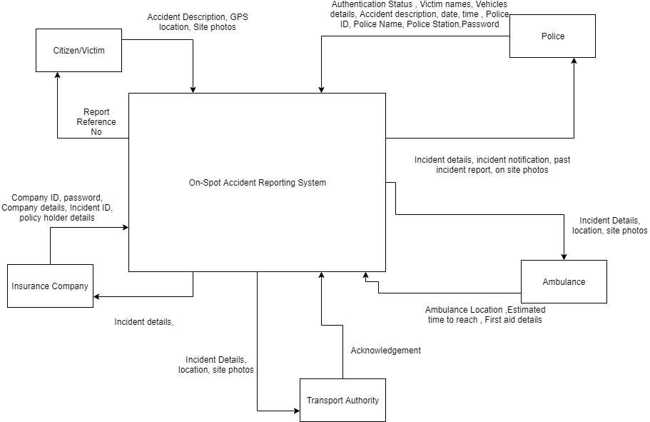

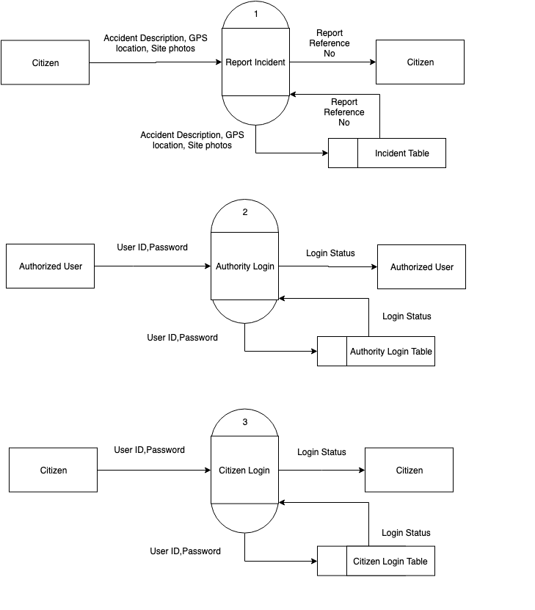

LEVEL 1:



LEVEL 1:

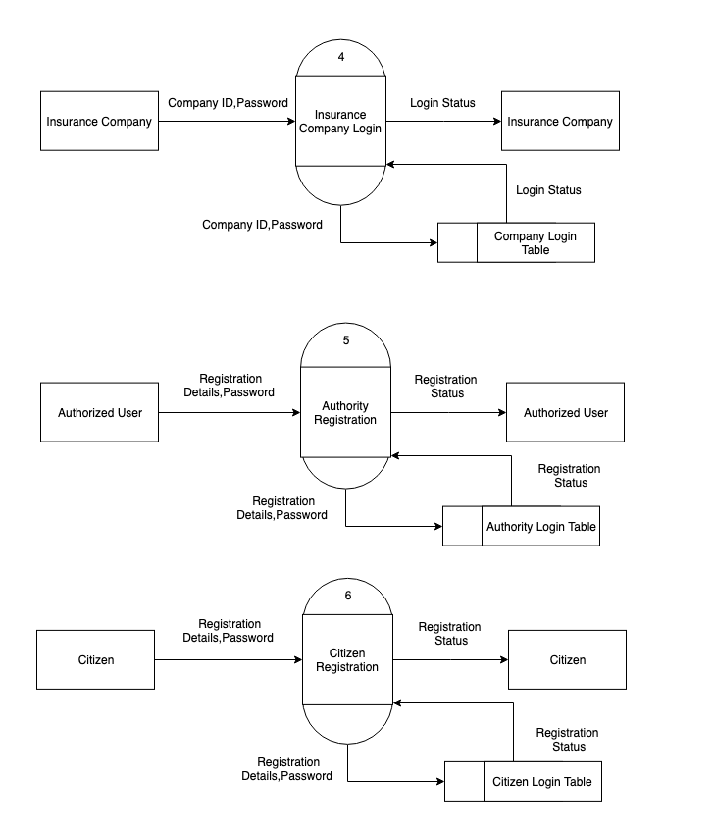

LEVEL 1:

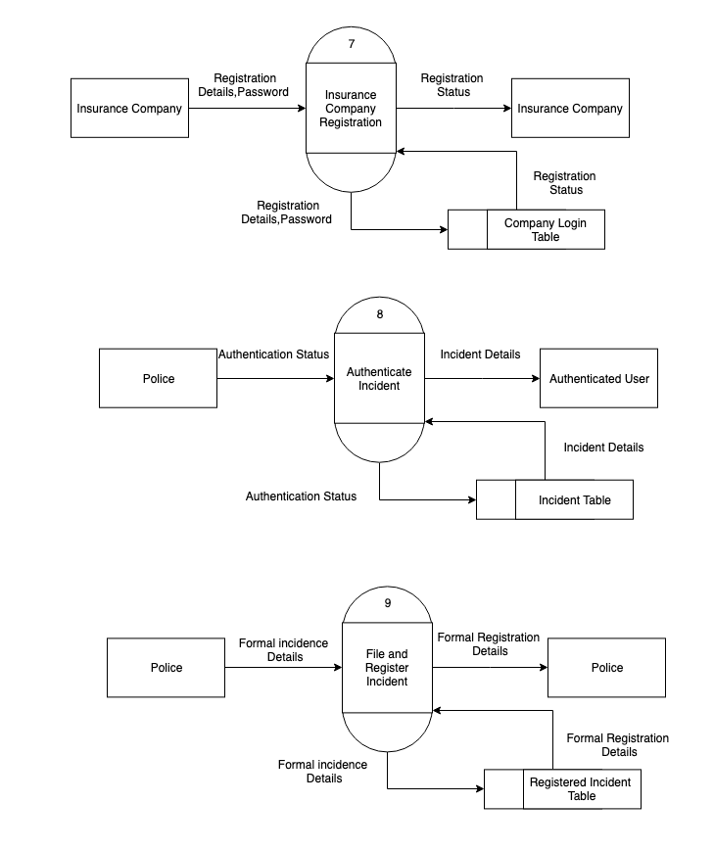

LEVEL 1:

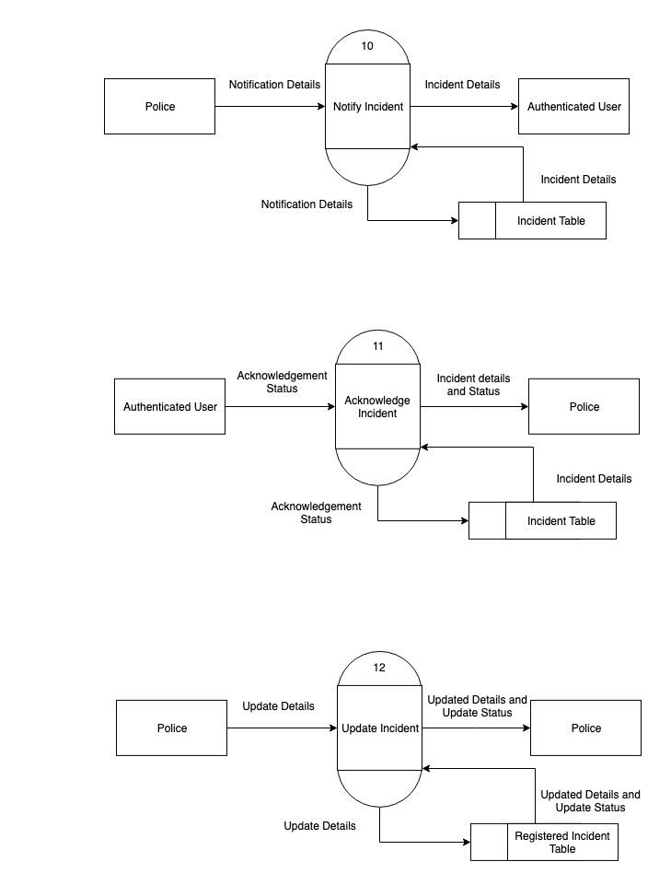

LEVEL 1:

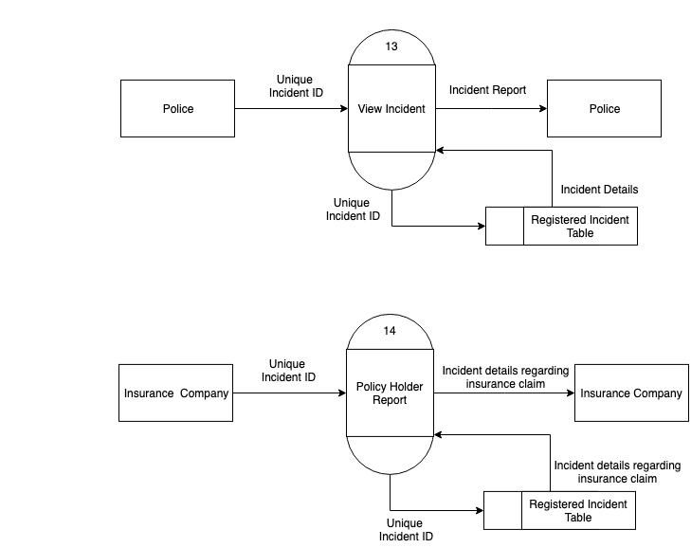

LEVEL 2:

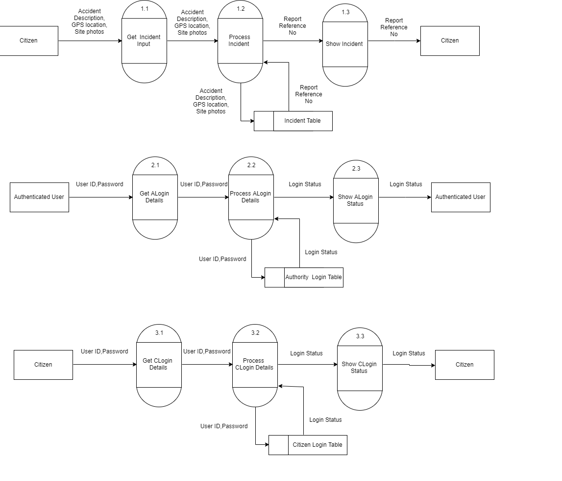

LEVEL 2:

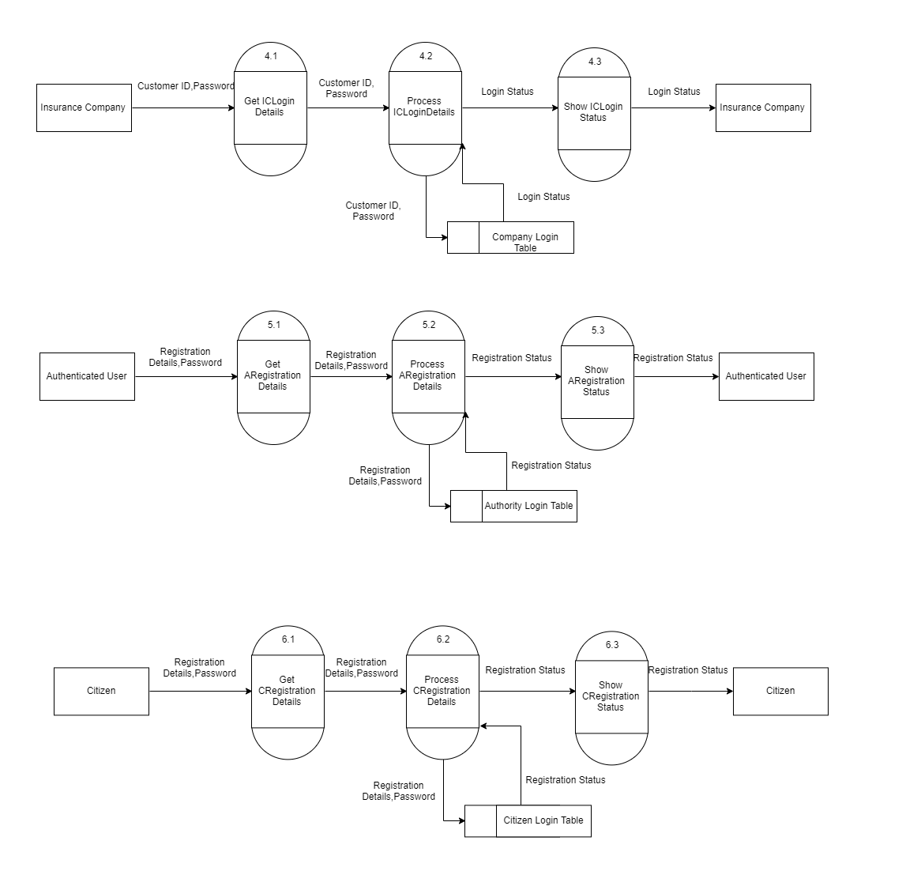

LEVEL 2:

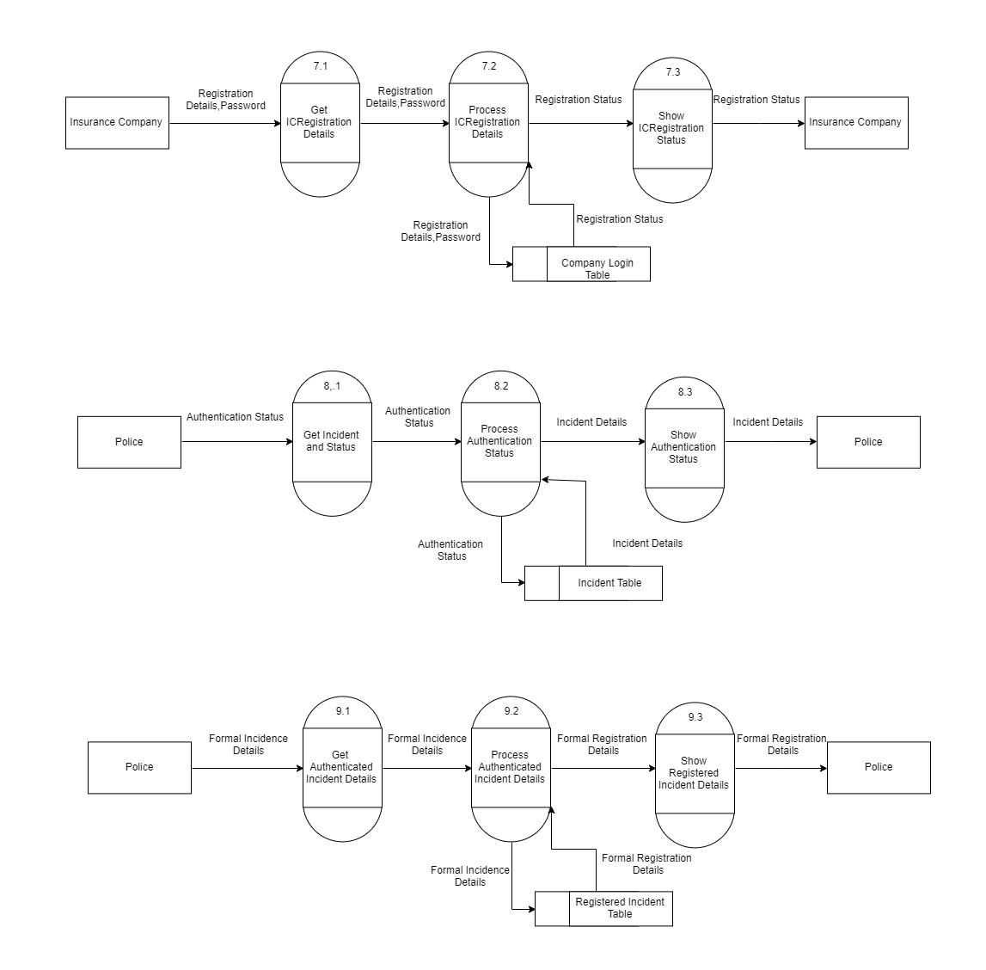

LEVEL 2:

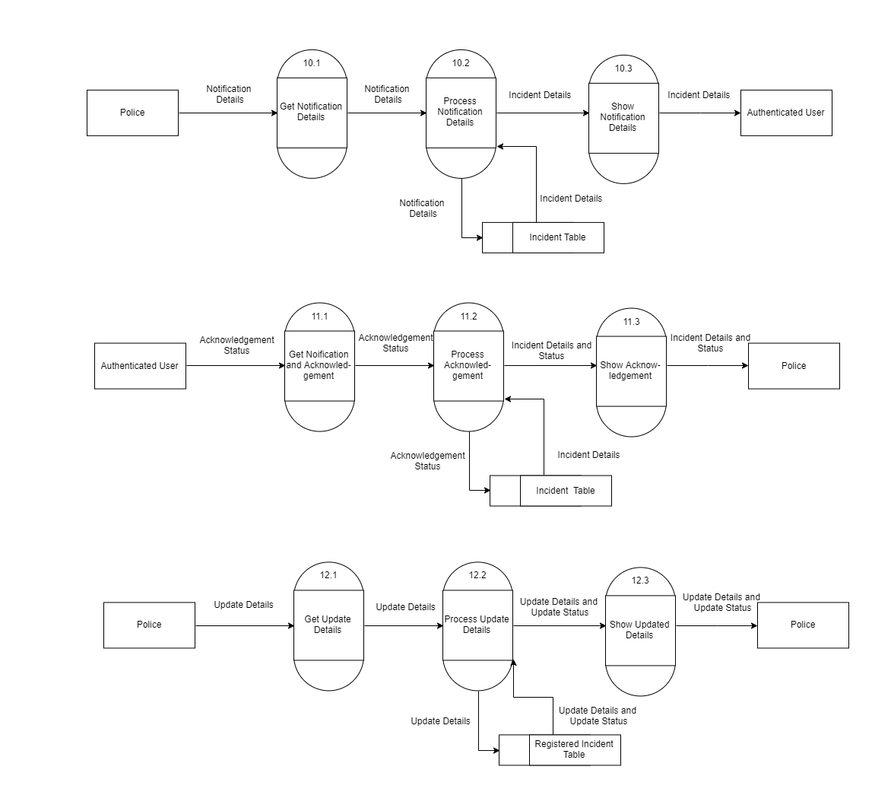

LEVEL 2:

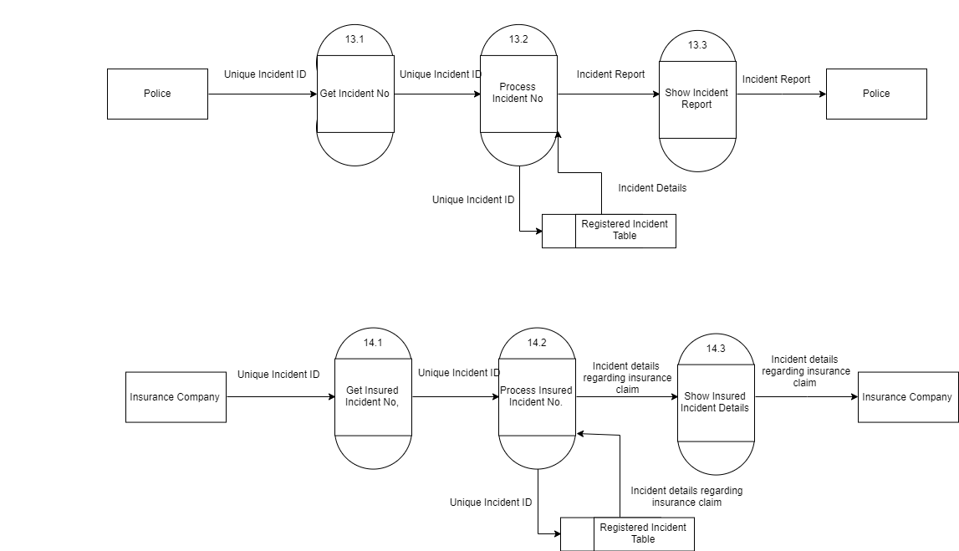

STRUCTURED CHART:

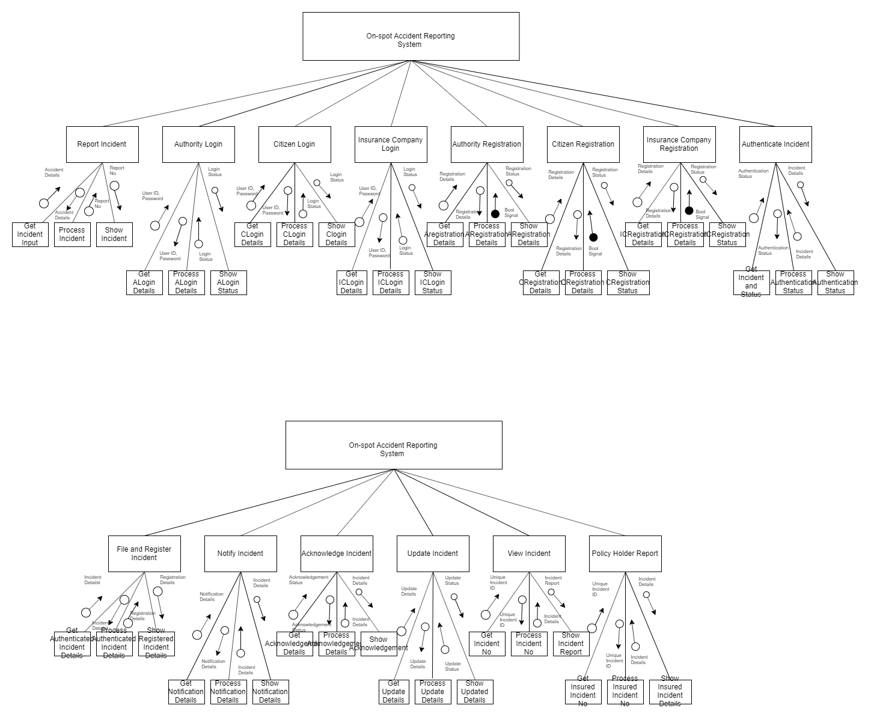

Appendix C: To be Determined List

<Collect a numbered list of the TBD (to be determined) references that remain in the SRS so they can be tracked to closure.>